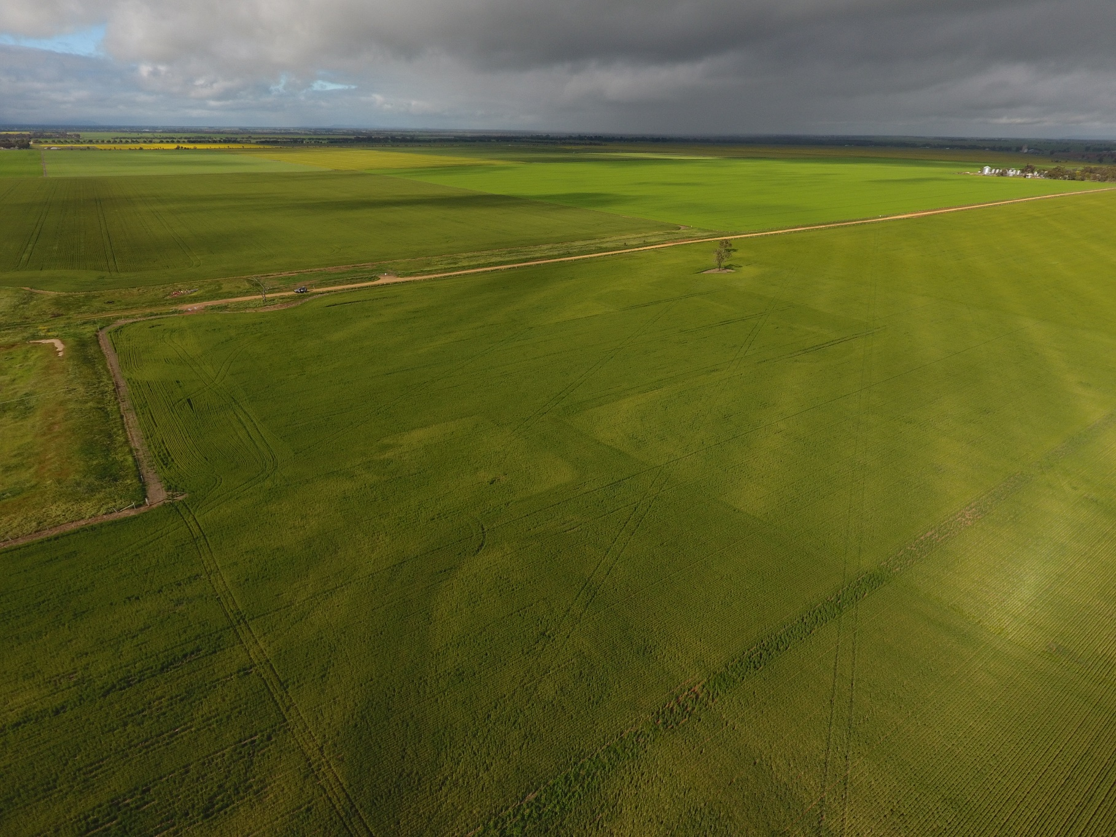
AVONBANK MINERAL SANDS PROJECT
AIR QUALITY

Air Quality Context
Effects on ambient air quality can occur naturally due to wind activity on exposed soils, as well as from sources such as pollen and bushfires. Soil disturbance from human activities can further contribute to and impact air quality.
Air quality is typically characterised based on particle size. Common classifications include particulate matter less than 10 micrometres (µm) in diameter (PM10) and fine particulate matter less than 2.5 µm in diameter (PM2.5).
Existing ambient dust levels (PM10 and PM2.5) were monitored within the Avonbank project area and were generally found to be below the air pollution assessment criteria published by the Environment Protection Authority (EPA). However, on several days throughout the year, PM10 levels exceeded the criteria due to high wind events combined with local farming activities.

Regulatory Framework
The EPA is responsible for regulating air pollution including dust emissions under the Environment Protection Act 2017 (EP Act) and the Environment Protection Regulations 2021 (EP Regs)
The EP Act includes a General Environmental Duty (GED) that applies to all entities engaging in activities that may give rise to risks of harm to human health or the environment from pollution or waste. The GED requires that a person who is engaging in an activity that may give rise to risks of harm minimise those risks so far as reasonably practicable.
An Air Quality Management Plan (AQMP) must be prepared in line with the commitments outlined in the Avonbank Environment Effects Statement (EES) and the recommendations made by the Minister for Planning in relation to the EES. The AQMP must be in place prior to project commencement

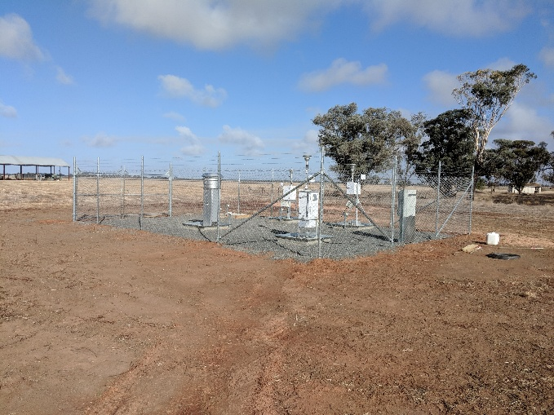 | 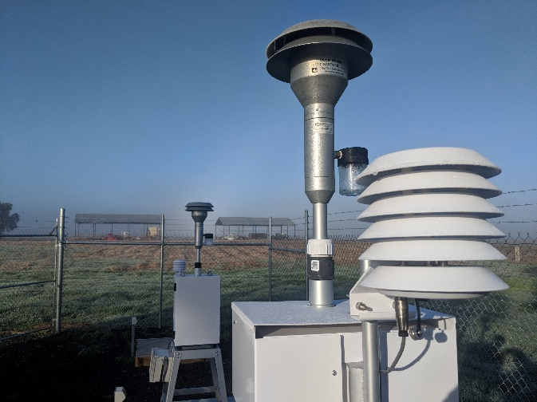
Air quality monitoring at Avonbank

Project Related Emissions
Atmospheric dispersion modelling was conducted for the EES to characterise the project's potential particulate matter contribution outside operational areas.
Over the 12-month modelling period, the project-related increment for PM10 and PM2.5 (24-hour average) was a relatively small fraction of the existing background levels and remained well below the EPA air pollution assessment criteria. The only exceedance of the criteria was related to the existing background levels (shown in orange below).
The average annual cumulative contribution (background plus project) remained below the EPA air pollution assessment criteria. Metals in deposited dust were found to pose a negligible risk to the general public and surrounding agricultural land.
An AQMP will be implemented to ensure the risk of harm to human health and the environment is avoided and minimised in line with regulatory requirements.

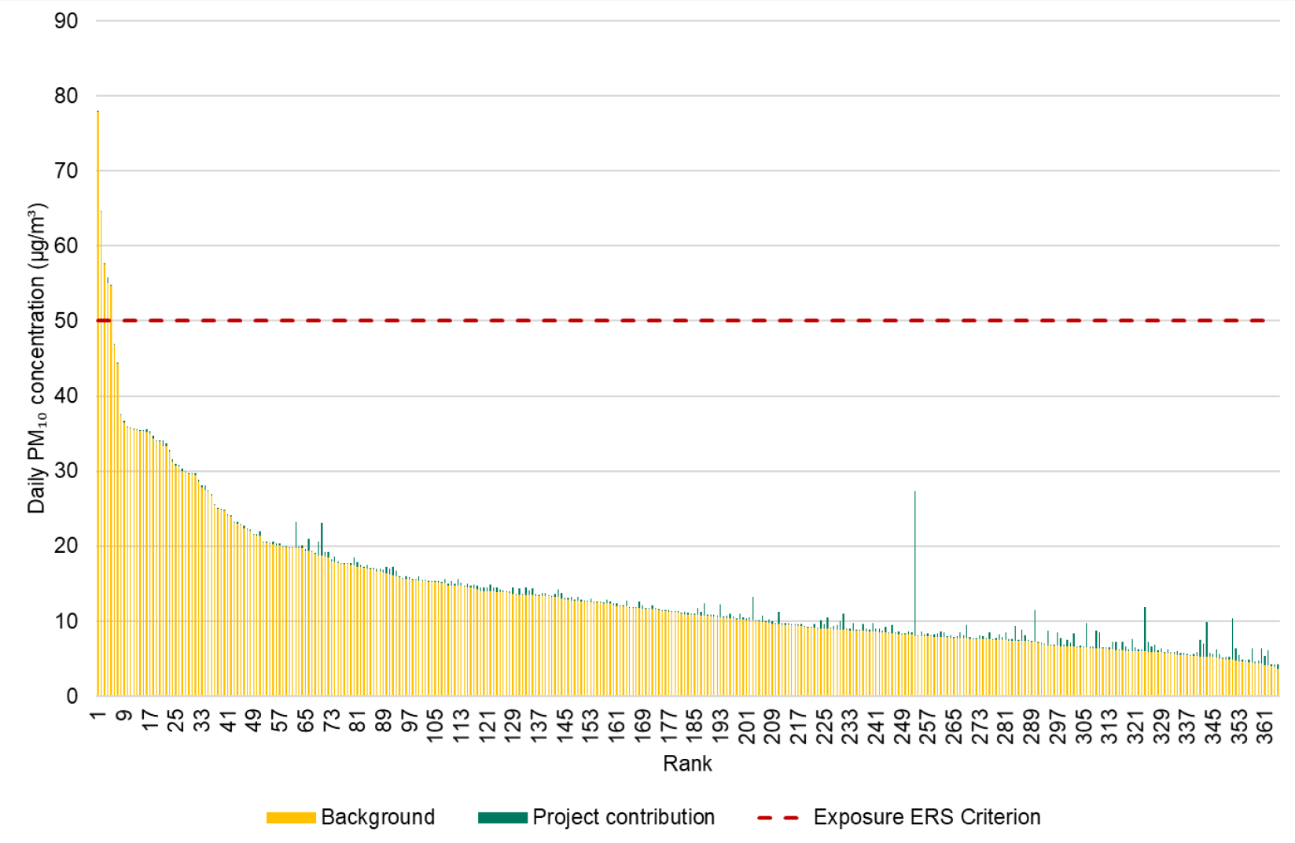
Indicative background PM10 (orange) and project increment (green) over 12 months at a near by receptor

Management Measures
Across site, dust emissions will be minimised using water carts to keep access roads moist, and disturbed areas will be progressively rehabilitated. Activities such as topsoil stripping will be timed to avoid high wind events.
The Heavy Mineral Concentrate (HMC) product will be stockpiled wet, and an automated sprinkler system with a failsafe backup will be maintained to ensure the HMC stockpile remains wet and is effectively stabilised to avoid dust emissions.
Monitoring will be undertaken to confirm project-related dust remains well below regulatory limits. This includes sampling at a reference-grade monitoring station and continuous particulate monitoring around site at sensitive receptors.
Depositional dust monitoring will be undertaken, as well as monitoring at rainwater tanks and cropping areas.
An AQMP will be developed to address the objectives of the relevant EPA guidelines and will need to be approved by the relevant regulatory authority prior to commencement.

Land Rehabilitation
Rehabilitation will be conducted as soon as possible following mining to enable the return of the disturbed area to its previous land use and to minimise areas exposed to wind erosion. At any given time, the extent of project disturbance will be less than 400 ha as areas are progressively mined and rehabilitated.
The land will be handed back to landholders once it has been suitably rehabilitated to a safe, stable and sustainable state and the end land use objective has been met. It is anticipated that for each mining cell, the land will be mined, backfilled and rehabilitated to a productive agricultural end land use within 4 years after mining.

Further Information
Community members are encouraged to visit the WIM Community Hub at 83 Firebrace Street Horsham to learn more about the project or get in contact via any of the means listed on the next page.

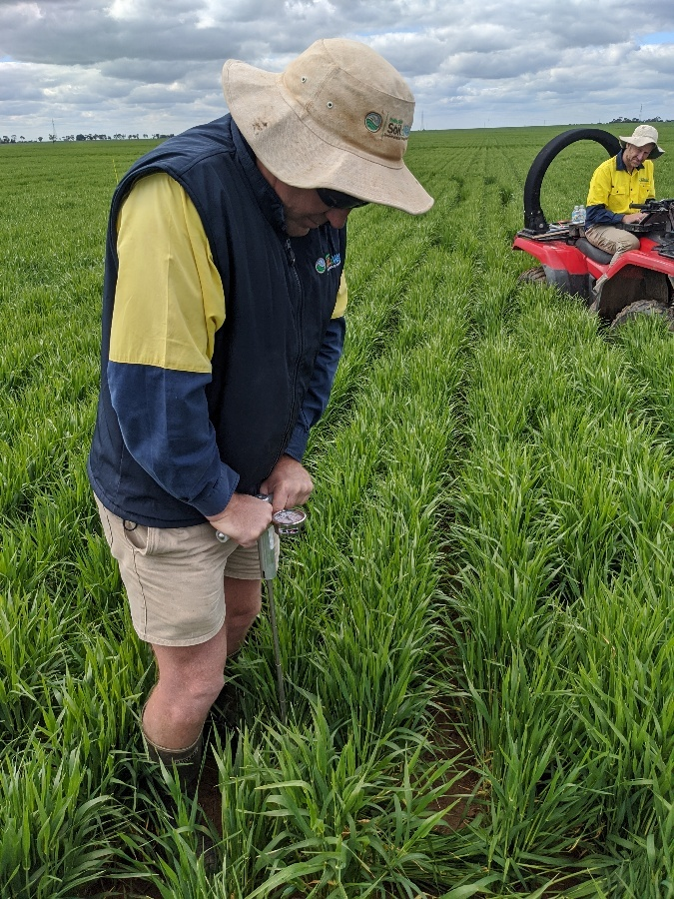
Post mine rehabilitation stabilised against wind erosion

Avonbank rehabilitation in foreground

_______________________________________________________________

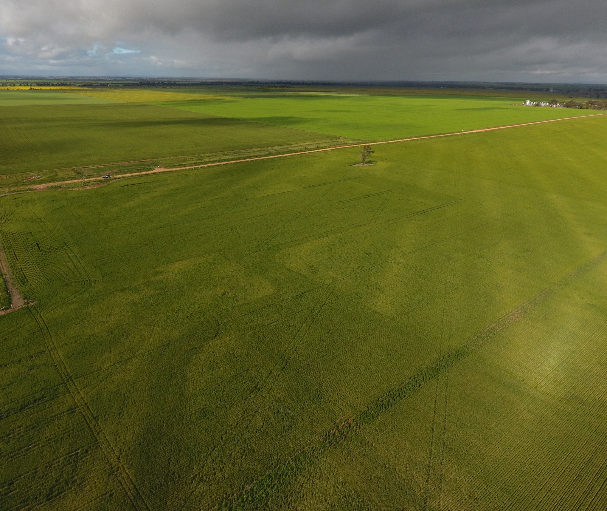
Contact WIM Community Hub
WIM Resource 83 Firebrace Street
Suite 2004, Level 20 Horsham Victoria 3400
201 Elizabeth Street 1800 959298
Sydney, NSW, 2000 Open to the general pulic
(02) 92641990 Mon – Friday 9am to 5pm
www.wimresource.com.au

